Integrate Zscaler with Identity Providers (IdPs) such as Azure AD, Okta, and Active Directory for seamless authentication and authorization.

List of Teammates:

S. No | NAME | COLLEGE | EMAIL ID
1. | Santhiya S | Adharsh Vidhyalaya College of Arts And Science for women | sivagobisandhya@gmail.com
2. | Divya S | Adharsh Vidhyalaya College of Arts And Science for women | dhivya2006dhivya@gmail.com
3. | Nathiya K | Adharsh Vidhyalaya College of Arts And Science for women | knathiya070@gmail.com
4. | Devayani M | Adharsh Vidhyalaya College of Arts And Science for women | m1998devayani@gmail.com

Project details:

Title: Integrate Zscaler with Identity Providers (IdPs) such as Azure AD, Okta, and Active Directory for seamless authentication and authorization.

Project Overview:

This project outlines the strategy and implementation plan for integrating the Zscaler security platform with our organization's core Identity Providers (IdPs): Microsoft Entra ID (Azure AD), Okta, and on-premises Active Directory (AD). The primary objective is to create a seamless, secure, and automated framework for user authentication and authorization across all Zscaler services.

By moving away from disparate local user management and leveraging these centralized identity sources, we aim to establish a true Zero Trust architecture where access is continuously verified based on user identity and context. This initiative will consolidate authentication into a single source of truth, enforce consistent security policies like Multi-Factor Authentication (MFA), and streamline the user experience through Single Sign-On (SSO).

Ultimately, this integration will serve as the critical link between our identity infrastructure and our security enforcement point, ensuring that the right users have the right level of secure access to the internet and applications, regardless of their location

Abstract:

This project details the integration of the Zscaler Internet security platform with leading Identity Providers (IdPs), including Microsoft Entra ID (Azure AD), Okta, and on-premises Active Directory (AD). The primary objective is to establish a unified identity framework that enables seamless Single Sign-On (SSO) and centralized authorization for all Zscaler services. By consolidating authentication into trusted corporate directories, this initiative eliminates the need for disparate credentials and provides a foundational element for a modern Zero Trust security architecture.

leveraging industry-standard protocols such as SAML, OIDC, and SCIM, this integration ensures that user authentication is delegated to trusted corporate directories while enforcing consistent security policies, including Multi-Factor Authentication (MFA). This approach not only enhances the user experience by reducing password fatigue but also strengthens the organization's security posture by ensuring that every access request is verified by the identity provider before reaching Zscaler's security enforcement points.

Furthermore, the implementation of automated user provisioning via SCIM streamlines lifecycle management, reducing administrative overhead and enhancing security posture. The outcome is a robust, identity-centric security model that aligns with Zero Trust principles, ensuring that only authenticated and authorized users gain secure access to internet and cloud applications from any location. This integration effectively bridges the gap between identity governance and network security, creating a dynamic and responsive access control environment.

Use Case Scenarios:

Use Case Scenario 1: Remote Faculty Access to Research Data

A research professor is working from an off-campus conference and needs secure access to sensitive research data stored on an internal server. Instead of connecting to the full campus network via VPN, ZPA grants access only to the specific research server. The professor authenticates via the university's identity provider, and access is granted based on their role.

Output:
- User identity verified: Research_Faculty_Group
- Context-aware access enforced: Access allowed only from non-campus IP ranges
- Connection restricted: Limited to specific Research File Server (R&D_Server)
- Security enforcement: Multi-Factor Authentication (MFA) required due to off-network location
- No lateral movement: User cannot access other internal systems such as HR or student records

Use Case Scenario 2: Student Access to Library Resources

A graduate student is off-campus and needs access to licensed academic journals and databases hosted internally. Instead of requiring a full VPN tunnel, ZPA provides direct access to the library application portal. The student authenticates via the identity provider, ensuring only enrolled students can access paid subscription content.

Output:
- User identity verified: Enrolled_Student_Group
- Access scope defined: Limited to Library Portal and journal databases
- Policy enforcement: Access restricted to authorized users only, preventing credential sharing
- User experience: Seamless SSO without additional VPN client complexity
- No broad network access: Student cannot navigate to administrative systems or internal servers

Use Case Scenario 3: HR Administrator Access to Payroll System

An HR administrator requires access to the payroll system to process monthly salaries. Access must be restricted to specific work hours and require step-up authentication due to the sensitivity of the data. The administrator authenticates via the identity provider, and ZPA enforces time-based and MFA policies.
Output:

- User identity verified: HR_Payroll_Group
- Time-based restriction enforced: Access permitted only during business hours (8:00 AM – 6:00 PM)
- Step-up authentication: MFA triggered upon accessing the payroll application
- Connection restricted: Limited to Payroll Application Server
- Audit trail: Full session logging maintained for compliance purposes

Use Case Scenario 4: IT Helpdesk Remote Troubleshooting

An IT support technician needs to remotely troubleshoot a server issue while working from home. ZPA provides Just-in-Time (JIT) access to the specific server requiring maintenance. The technician authenticates via the identity provider, and administrative privileges are granted only for the duration of the task.

Output:
- User identity verified: IT_Helpdesk_Group
- Just-in-Time access granted: Admin rights elevated only for the active session
- Connection restricted: Limited to the specific target server (Server-X)
- Privilege boundaries enforced: No access to other infrastructure components (databases, domain controllers)
- Session monitoring: Real-time activity logging for security review

Use Case Scenario 5: Contractor Access to Project Management Tool

An external project manager contracted for a specific initiative needs access to the university's project management tool (e.g., Jira or SharePoint). Access must expire automatically upon contract completion. The contractor authenticates via the identity provider, and ZPA provisions time-limited access based on group membership synchronized from Azure AD.

Output:
- User identity verified: External_Contractor_Group
- Time-bound access policy enforced: Account deprovisioned automatically after contract end date
- Connection restricted: Limited to Project Management Application only
- Segmentation enforced: Contractor cannot discover or access internal resources like finance systems or student databases

Stage-1

Title of the Project:

Replace and modernize legacy VPN architectures with a cloud-native Zscaler Zero Trust solution to reduce attack surface and lateral movement.

Overview: -

The integration of Zscaler with enterprise Identity Providers (IdPs) represents a fundamental shift in how organizations approach secure access to applications and resources. Traditional network security models relied on VPNs and perimeter-based defenses, which often granted excessive access and created lateral movement risks. By contrast, this project leverages Zscaler's Zero Trust Exchange platform to verify identity at the application layer rather than the network layer. The integration with leading IdPs such as Microsoft Entra ID, Okta, and on-premises Active Directory establishes a unified identity fabric across the organization. This ensures that users are authenticated consistently regardless of their location or device. The project eliminates the need for duplicate user directories and manual account management within Zscaler. It creates a seamless experience where users authenticate once and gain access to authorized resources. Security teams benefit from centralized control over authentication policies and user lifecycle management. The integration supports modern authentication standards including SAML, OIDC, and SCIM protocols. Ultimately, this foundation enables true Zero Trust security where identity becomes the primary control plane.

Microsoft Entra ID integration serves as a cornerstone of this identity strategy for organizations heavily invested in the Microsoft ecosystem. The integration leverages SAML 2.0 to establish federated trust between Zscaler and Azure AD for seamless Single Sign-On. Users accessing Zscaler Internet Access or Zscaler Private Access portals are redirected to Azure AD for authentication. This allows organizations to enforce Azure AD Conditional Access policies during the authentication flow. Policies can require compliant devices, specific locations, or risk-based access controls before granting access to Zscaler. The integration extends beyond authentication to include automated user provisioning via the SCIM protocol. User accounts and group memberships are synchronized in real-time from Azure AD to Zscaler. This automation eliminates manual provisioning errors and ensures immediate deprovisioning when users leave the organization. Azure AD's extensive reporting and auditing capabilities provide visibility into authentication attempts. The result is a tightly integrated security posture that leverages Microsoft's identity capabilities to protect Zscaler-enforced resources.
Okta integration provides a flexible and vendor-agnostic approach to identity management for

Zscaler deployments. As a leading independent Identity Provider, Okta connects Zscaler to a wide ecosystem of applications and directories. The integration utilizes OpenID Connect (OIDC) for modern, API-friendly authentication to Zscaler services. This approach supports rich user context
including profile attributes and group memberships for policy enforcement. Okta's Universal Directory serves as the authoritative source for user identities synchronized from various HR systems and directories. The Okta Integration Network (OIN) simplifies setup with pre-built connectors and configuration guides for Zscaler. Automated provisioning via SCIM ensures that user changes in Okta are reflected in Zscaler within minutes. Lifecycle management events such as user onboarding, role changes, and terminations trigger automatic updates in Zscaler. Okta's adaptive MFA policies add an additional security layer during Zscaler authentication requests. This integration delivers a seamless experience for users while providing administrators with centralized identity governance across all Zscaler services.

On-premises Active Directory integration addresses scenarios where organizations are not ready for full cloud identity migration. Many institutions maintain extensive on-premises infrastructure with complex group policies and nested organizational units. The Zscaler Authentication Bridge (ZAB) enables secure LDAP communication between Zscaler cloud services and on-premises AD. This lightweight connector sits behind the firewall and initiates outbound connections to Zscaler, eliminating the need for inbound firewall rules. User authentication requests are securely proxied through ZAB to validate credentials against the on-premises domain controllers. Group membership information is synchronized to Zscaler for use in policy definitions and access decisions. This approach preserves investments in existing Active Directory infrastructure while enabling cloud-delivered security. Organizations can maintain strict access controls based on on-premises group memberships and organizational hierarchies.
List of Vulnerability Table:

S.No | Category Name | Vulnerability Name | CWE/CVE-No
1. | Broken Access Control | Incorrect Default Permissions | CWE-276
2. | Security Misconfiguration | Password in configuration file | CWE-260
3. | Software Supply Chain Failures | Use Of Obsolete Function | CWE-447
4. | Cryptographic Failures | Missing Required Crptographic Step | CWE-325
5. | Injection | Improper input Validation | CWE-20
6. | Insecure Design | Interpretation Conflict | CWE-436
7. | Authentication Failures | Improper Certificate Validation | CWE-295
8. | Software or Data Integrity Failures | Untrusted Search Path | CWE-426
9. | Security Logging & Alerting Failures | Information Loss of Omission | CWE-221
10. | Mishandling of Exceptional Conditions | Unchecked Error Condition | CWE-391
REPORT:-
- Vulnerability Name: Incorrect Default Permissions

CWE NUMBER: CWE-276

OWASP Category: A01:2025 Broken Access Control

Description:

Access control enforces policy such that users cannot act outside of their intended permissions. Failures typically lead to unauthorized information disclosure, modification or destruction of all data, or performing a business function outside the user's limits.
Bussiness Impact:
Broken access control can allow unauthorized users to access sensitive business data and systems. This may lead to the exposure or theft of confidential customer information. Such incidents can cause financial losses and seriously damage

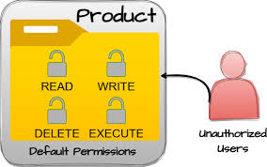

Recommendation:
- Implement proper authentication and authorization mechanisms.
- Follow the principle of least privilege so users only get necessary access.
- Regularly review and update user roles and permissions.
- Use strong access control checks on both server side and application level.
- Conduct regular security testing and monitoring to detect unauthorized access.

- Vulnerability Name: Password in configuration file

CWE NUMBER: CWE-260

OWASP Category: A02:2025 Security Misconfiguration

Description :
Security misconfiguration occurs when security settings in applications, servers, or databases are not properly configured. This can leave systems vulnerable to attackers and expose sensitive information. Common causes include default configurations, unnecessary services, open cloud storage, and improper permissions. Attackers can exploit these weaknesses to gain unauthorized access or control over the system. Proper configuration and regular security checks are necessary to prevent such risks.
Bussiness Impact:
If a password is stored in a configuration file, attackers who gain access to the system can easily retrieve the credentials. This can lead to unauthorized access to important systems, databases, or applications. Sensitive business data may be stolen, modified, or deleted, causing serious data breaches. It can also result in financial loss and damage to the organization’s reputation. Additionally, the company may face legal and compliance issues due to poor security practices. 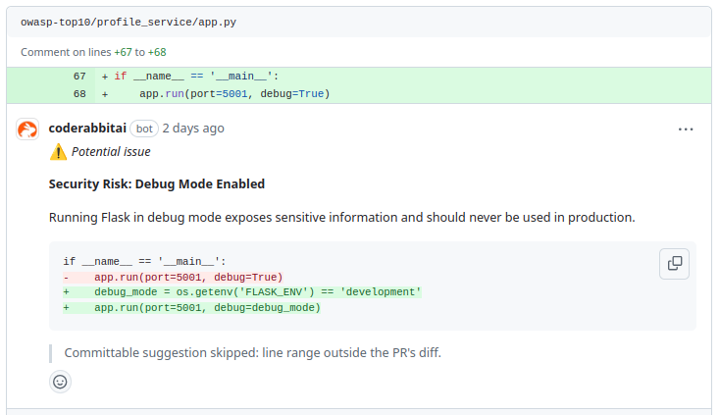

Recommendations:
- Change default usernames, passwords, and configurations.
- Disable unnecessary services, features, and ports.
- Keep software, servers, and frameworks updated regularly.
- Implement proper security headers and configuration settings.
- Perform regular security audits and vulnerability scans.

- Vulnerability Name: Use of Obsolete function
CWE NUMBER: CWE-260

OWASP Category: A03:2025 Software Supply Chain Failures

Description:
Software Supply Chain Failures occur when vulnerabilities or malicious code enter an application through third-party components, libraries, or dependencies. Many modern applications depend on external packages and open-source software. If these components are not properly verified or updated, attackers can exploit them to compromise the system. This can lead to data breaches, malware injection, or system disruption. Proper management and monitoring of third-party software are essen0tial to reduce these risks. ;
Bussines Impact:
Using obsolete or outdated functions in software can create security weaknesses that attackers may exploit. This may allow unauthorized users to access or manipulate the system, leading to potential data breaches. It can affect the reliability and stability of business applications, causing system failures or downtime. Such vulnerabilities may result in financial losses and reduced customer trust. Additionally, the organization could face compliance and regulatory issues due to insecure software components.

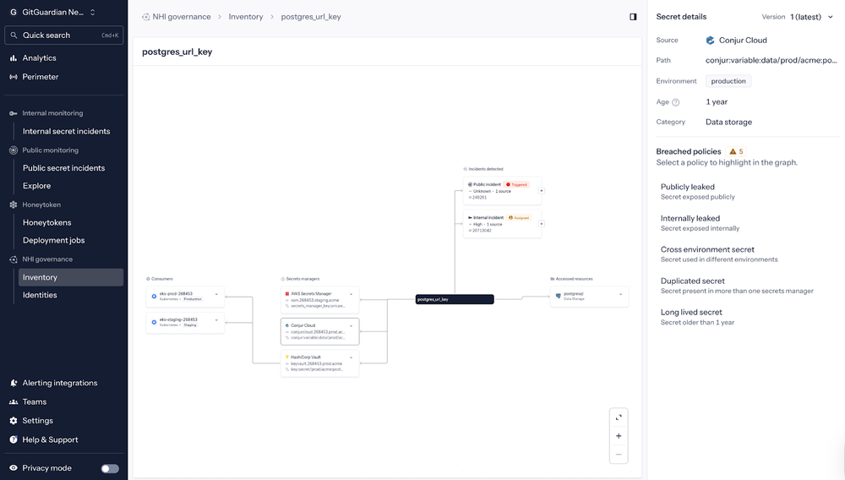

Recommendations:
- Use trusted and verified third-party libraries and components.
- Regularly update and patch all software dependencies.
- Monitor and scan components for known vulnerabilities.
- Maintain a Software Bill of Materials (SBOM) for all dependencies.
- Implement secure development and supply chain security practices.

- Vulnerability Name: Missing Required cryptographic step
CWE NUMBER: CWE-325

OWASP Category : A04:2025 Cryptographic Failures

Description:
Cryptographic failures occur when sensitive data is not properly protected using encryption. This happens when weak encryption methods, poor key management, or missing encryption are used. As a result, attackers may access confidential data such as passwords, personal information, or financial details. Data transmitted over networks can also be intercepted if it is not securely encrypted. Proper cryptographic practices are important to protect sensitive information and maintain data security.

Bussiness Impact:
If a required cryptographic step is missing, sensitive data may not be properly protected during storage or transmission. Attackers could intercept, read, or manipulate confidential information such as passwords or financial data. This can lead to data breaches and unauthorized access to critical business systems. As a result, the organization may suffer financial losses and damage to its reputation. It may also cause legal and compliance problems due to failure in maintaining proper data security.

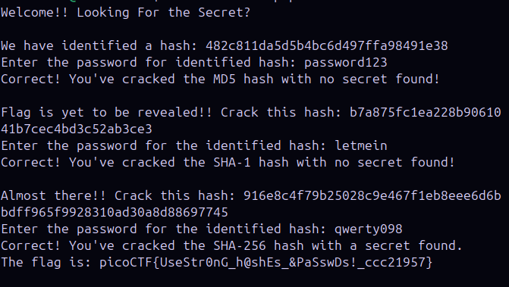

Recommendations:
- Use strong and updated encryption algorithms to protect sensitive data.
- Encrypt sensitive data both in transit and at rest.
- Implement proper cryptographic key management practices.
- Avoid storing sensitive data in plain text.
- Regularly review and update cryptographic protocols and security measures.

- Vulnerability Name: Improper input validation
CWE NUMBER: CWE-20

OWASP Category : A05:2025 Injection

Description:

Injection is a security vulnerability where an attacker sends malicious input to an application. This input is then executed as a command or query by the system. It commonly occurs in databases, operating systems, and interpreters such as SQL, NoSQL, or OS commands. Because the application does not properly validate user input, attackers can manipulate queries and access sensitive data. Injection attacks can lead to data theft, data modification, or complete system compromise.

Bussiness Impact:

Improper input validation allows attackers to inject malicious data or commands into the system. This can lead to unauthorized access, data manipulation, or system compromise. Sensitive business information may be stolen, altered, or deleted, resulting in data breaches. It can also cause application failures or service disruptions, affecting business operations. As a result, the organization may face financial loss, reputational damage, and compliance issues.
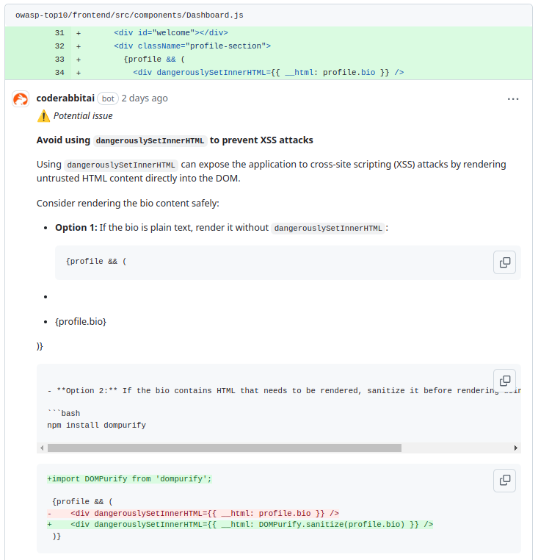
Recommendations:
- Always validate and sanitize all user inputs before processing.
- Use parameterized queries / prepared statements instead of dynamic queries.
- Implement proper input validation using allow-list techniques.
- Use secure frameworks and libraries that automatically prevent injection.
- Apply the principle of least privilege for database and system access.

- Vulnerability Name: Interpretation Conflict

CWE NUMBER: CWE-436

OWASP Category : A06:2025 Insecure Design

Description:

Interpretation Conflict occurs when different components of a system interpret the same input or data in different ways. This usually happens when there is no clear design standard for how data should be processed between modules, servers, or applications. Attackers can exploit this difference to bypass security controls or validation mechanisms. As a result, the system may process malicious input as valid data. This vulnerability mainly arises due to insecure design and lack of proper validation rules.

Bussiness Impact:
Interpretation conflicts can allow attackers to bypass security checks and gain unauthorized access to the system. This may lead to data manipulation, data leakage, or unauthorized operations. Important business applications may behave incorrectly or unpredictably, affecting service reliability. Such issues can cause financial loss and disruption to business operations. It can also damage the organization’s reputation and customer trust.
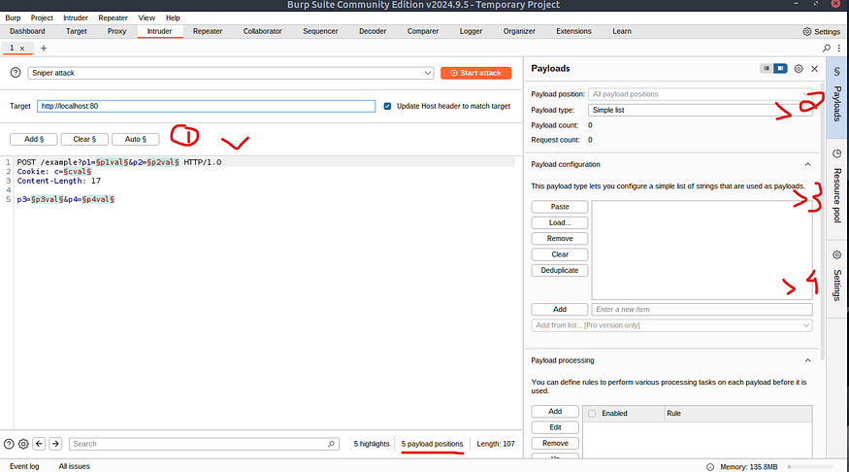

Recommendations:
- Implement consistent input validation rules across all system components.
- Ensure standardized data formats and encoding are used throughout the application.
- Perform secure design reviews and threat modeling during the development phase.
- Conduct regular security testing and code reviews to detect interpretation conflicts.
- Use secure frameworks and libraries that enforce proper data handling and validation.

- Vulnerability Name: Improper Certificate validation

CWE NUMBER: CWE-295

OWASP Category : A07:2025 Authentication Failures

Description:
Improper Certificate Validation occurs when an application fails to properly verify the authenticity of a digital certificate during secure communication. The system may accept invalid, expired, or untrusted certificates without proper checks. This weakness can allow attackers to perform Man-in-the-Middle (MITM) attacks. As a result, attackers may intercept or alter the data being transmitted between systems. This vulnerability usually occurs due to insecure design or improper SSL/TLS validation implementation.

Bussiness Impact:
If certificate validation is not properly implemented, attackers can intercept sensitive communication between users and the system. Confidential information such as login credentials, personal data, or financial details may be exposed. This can lead to data breaches and unauthorized access to business systems. Organizations may suffer financial losses and damage to customer trust. It may also cause legal and compliance issues related to data protection.

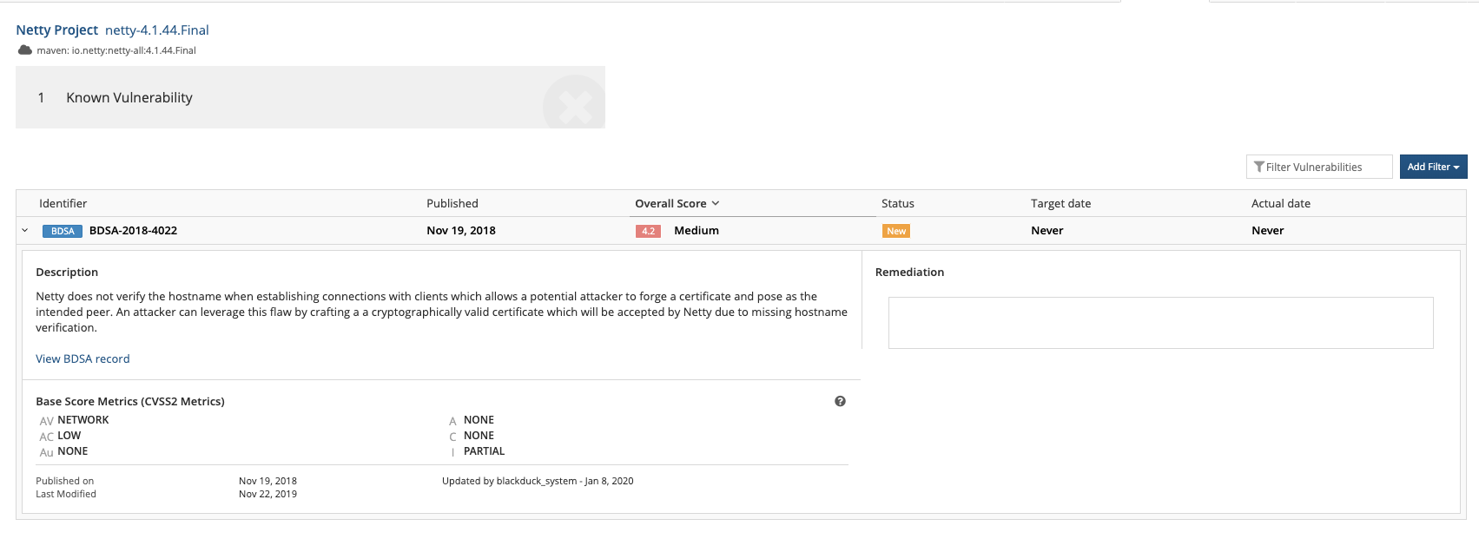

Recommendations:
- Ensure the application properly validates SSL/TLS certificates before establishing secure connections.
- Verify certificate authority (CA), expiration date, and certificate chain during validation.
- Avoid disabling certificate validation checks in production environments.
- Use trusted certificate authorities and implement certificate pinning where possible.
- Conduct regular security testing and code reviews to ensure secure certificate handling.

- Vulnerability Name: Untrusted search path

CWE NUMBER: CWE-426

OWASP Category : A08:2025 Software or Data Integrity Failures

Description:
Untrusted Search Path occurs when an application loads executables or libraries from a location that is not trusted or properly verified. The system may search for files in multiple directories without checking their authenticity. Attackers can place malicious files in these locations, which may be executed by the application instead of legitimate files. This can lead to unauthorized code execution on the system. The issue usually arises due to improper configuration and lack of secure file path validation

Bussiness Impact:
If attackers exploit an untrusted search path, they can execute malicious code within the application environment. This may allow them to gain unauthorized access or control over the system. Sensitive business data may be stolen, modified, or deleted. It can also cause system compromise or service disruption, affecting business operations. As a result, the organization may face financial loss and reputational damage.

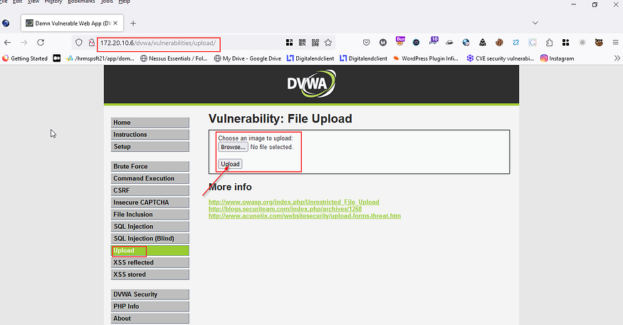

Recommendations
- Use absolute and trusted file paths when loading executables or libraries.
- Restrict application access to trusted directories only.
- Implement proper file integrity checks before executing files.
- Remove unnecessary directories from the system search path.
- Conduct regular security audits and configuration reviews to identify such vulnerabilities.

- Vulnerability Name: Information loss of Omission

CWE NUMBER: CWE-221

OWASP Category : A09:2025 Security Logging & Alerting Failures

Description:

Information Loss of Omission occurs when important security-related information is not properly logged or recorded by the system. Critical events such as login attempts, errors, or suspicious activities may not be captured in logs. This usually happens due to improper logging configuration or incomplete monitoring mechanisms. Without proper logs, it becomes difficult to track system activities or detect security incidents. This vulnerability falls under logging and monitoring failures in system design.

Bussiness Impact:
If important events are not logged, security incidents may go undetected for a long time. Attackers may perform malicious activities without being noticed by administrators. This can lead to data breaches, unauthorized access, or system misuse. It also makes incident investigation and forensic analysis very difficult. As a result, the organization may face financial loss, operational disruption, and reputational damage.

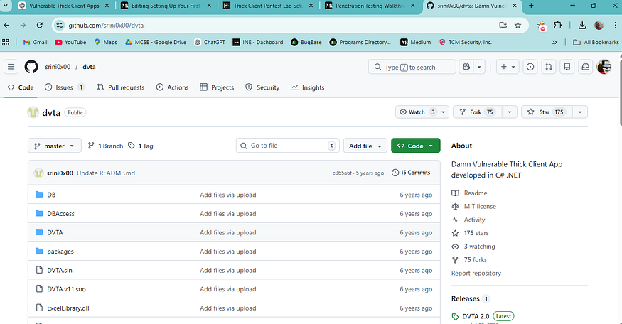

Recommendations:
- Implement proper security logging for all critical system activities.
- Ensure logs capture login attempts, errors, and suspicious actions.
- Use centralized logging and monitoring systems for better visibility.
- Regularly review and analyze logs to detect unusual activities.
- Set up alert mechanisms to notify administrators about potential security incidents.

- Vulnerability Name: Unchecked error condition

CWE NUMBER: CWE-391

OWASP Category : A10:2025 Mishandling of Exceptional Conditions

Description:
Unchecked Error Condition occurs when an application fails to properly check or handle errors during execution. When an error happens, the system may continue running without proper validation or response. This can cause the application to behave unpredictably or enter an insecure state. Attackers may exploit these unhandled errors to trigger system failures or bypass security controls. This vulnerability usually occurs due to poor error handling in the application design or code.

Bussines Impact:

If errors are not properly handled, the application may crash or behave unexpectedly, affecting normal operations. Attackers may exploit these weaknesses to cause system disruptions or gain unauthorized access. It can lead to data corruption, data loss, or service downtime. Such issues can negatively impact business productivity and customer experience. As a result, the organization may face financial loss and reputational damage.
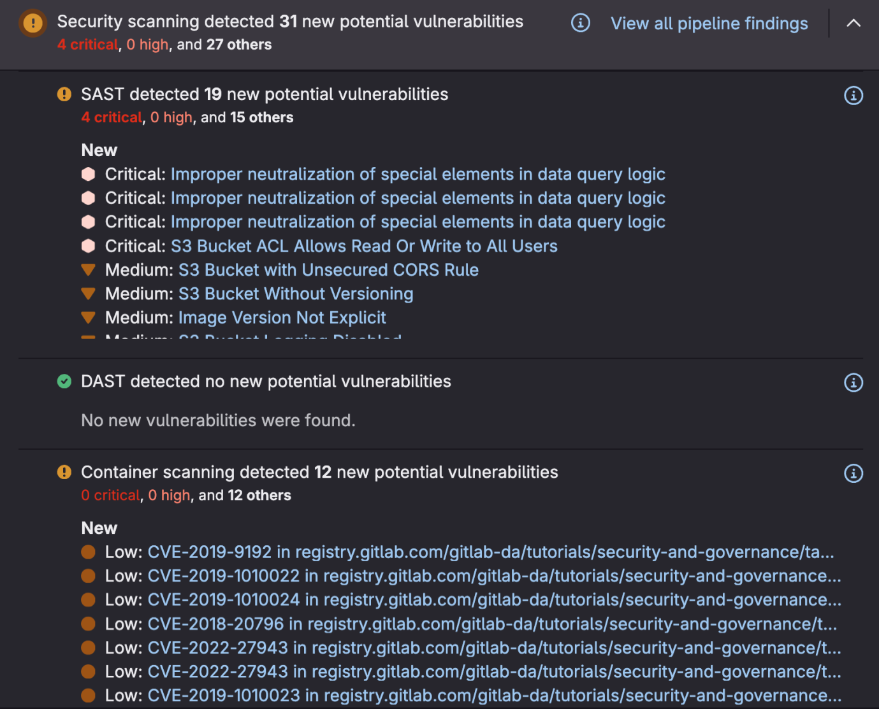

Recommendations:
- Implement proper error handling mechanisms in the application code.
- Ensure all error conditions are checked and handled appropriately.
- Log errors securely for monitoring and troubleshooting purposes.
- Avoid exposing sensitive system information in error messages.
- Perform regular code reviews and testing to identify unhandled errors.

STAGE-2

OVERVIEW:
Nessus is one of the most widely used vulnerability scanning tools in the field of cybersecurity. It is developed by the company Tenable and is mainly used to identify security weaknesses in computer systems, networks, applications, and devices. The main purpose of Nessus is to help organizations detect vulnerabilities before attackers exploit them. It performs automated scans and provides detailed reports about security issues, misconfigurations, outdated software, and other potential threats.
From my understanding, Nessus works by scanning a target system such as a server, computer, or network device and comparing it with a large vulnerability database. This database contains thousands of known security issues, including vulnerabilities listed in the Common Vulnerabilities and Exposures (CVE) and weaknesses categorized under Common Weakness Enumeration (CWE). During the scanning process, Nessus checks open ports, running services, software versions, and system configurations. If it finds any known vulnerability, it reports the issue along with its severity level and possible solutions.
Nessus is capable of performing different types of scans such as network scanning, vulnerability scanning, compliance scanning, and configuration auditing. It supports scanning of various operating systems including Windows, Linux, and macOS. It can also detect vulnerabilities in web applications, databases, and network devices like routers and firewalls. The tool uses regularly updated plugins which allow it to detect the latest security vulnerabilities and threats.
Another important feature of Nessus is its detailed reporting system. After completing a scan, the tool generates reports that show vulnerabilities based on severity levels such as Critical, High, Medium, and Low. Each vulnerability report includes a description of the issue, its possible impact on the system, and recommended solutions to fix the problem. This helps security teams understand the risk level and prioritize which vulnerabilities should be fixed first.
Nessus is very useful for penetration testers, security analysts, and system administrators. It helps them regularly check their systems for security weaknesses and improve their overall security posture. By identifying vulnerabilities early, organizations can prevent data breaches, protect sensitive information, and maintain the reliability of their systems.
In conclusion, Nessus is a powerful vulnerability assessment tool that plays a significant role in modern cybersecurity practices. It helps organizations detect security weaknesses, maintain secure systems, and reduce the chances of cyberattacks by providing accurate vulnerability detection and remediation guidance.

Target Website: http://zero.webappsecurity.com
Target Ip Address: 54.82.22.214
List Of Vulnerability:
S.No | Vulnerability Name |  | Severity | Plugins
1. | TLS Version 1.0 protocol Detection |  | MEDIUM | 104743
2. | SSL Certificate cannot be trusted |  | MEDIUM | 51192
3. | SSL Certificate Expiry |  | MEDIUM | 15901
4. | Apache Tomcat 7.0.0<7.0.100 multiple valnerabilities |  | CRITICAL | 197843
5. | SSL/TLS Renegotiation Handshakes MiTM Plaintext Data Injection |  | MEDIUM | 42880
6. | SSL/TLS Versions Supported |  | INFO | 56984
7. | SSL/TLS Recommended Cipher suites |  | INFO | 156899
8. | SSL Medium Strength Cipher suites supported(SWEET32) |  | HIGH | 42873
9. | SSL RC4 Cipher Suites Supported(Bar Mitzvah) |  | MEDIUM | 65821
10. |  | SSL Compression Methods Supported | INFO | 62563

REPORT:
1)Vulnerability Name: TLS Version 1.0 protocol detection
Severity: MEDIUM
Plugin: 104743
Port: 443
Description:

The remote service accepts connections encrypted using TLS 1.0. TLS 1.0 has a number of cryptographic design flaws. Modern implementations of TLS 1.0 mitigate these problems, but newer versions of TLS like 1.2 and 1.3 are designed against these flaws and should be used whenever possible.

As of March 31, 2020, Endpoints that aren't enabled for TLS 1.2 and higher will no longer function properly with major web browsers and major vendors.

PCI DSS v3.2 requires that TLS 1.0 be disabled entirely by June 30, 2018, except for POS POI terminals (and the SSL/TLS termination points to which they connect) that can be verified as not being susceptible to any known exploits.

Solution:

Enable support for TLS 1.2 and 1.3, and disable support for TLS 1.0

Bussiness Impact:
- Data Security Risk: TLS 1.0 is an outdated encryption protocol that has known security weaknesses. Attackers may exploit these weaknesses to intercept sensitive information such as login credentials, personal data, or financial details during transmission.
- Compliance Issues: Many security standards such as PCI-DSS and other regulatory frameworks do not allow the use of TLS 1.0. Using this protocol may lead to compliance violations and possible legal or financial penalties.
- Reputation Damage: If attackers exploit the vulnerability and compromise user data, it can reduce customer trust and damage the organization’s reputation.
- Man-in-the-Middle Attacks: TLS 1.0 can be vulnerable to attacks like MITM (Man-in-the-Middle) where attackers can intercept or modify communication between users and the server.
- Operational Risk: Continuing to use outdated security protocols may increase the risk of future cyberattacks, which could lead to system downtime, service disruption, and financial loss for the business.

2)Vulnerability Name: SSL Certificate cannot be trusted
Severity: MEDIUM
Plugin: 51192
Port: 443

Description:
The server's X.509 certificate cannot be trusted. This situation can occur in three different ways, in which the chain of trust can be broken, as stated below:

-First, the top of the certificate chain sent by the server might not be descended from a known public certificate authority. This can occur either when the top of the chain is an unrecognized, self-signed certificate, or when intermediate certificates are missing that would connect the top of the certificate chain to a known public certificate authority,

-Second, the certificate chain may contain a certificate that is not valid at the time of the scan. This can occur either when the scan occurs before one of the certificate's 'notBefore' dates, or after one of the certificate's notAfter' dates.

- Third, the certificate chain may contain a signature that either didn't match the certificate's information or could not be verified. Bad signatures can be fixed by getting the certificate with the bad signature to be re-signed by its issuer. Signatures that could not be verified are the result of the certificate's issuer using a signing algorithm that Nessus either does not support or does not recognize.

If the remote host is a public host in production, any break in the chain makes it more difficult for users to verify the authenticity and identity of the web server. This could make it easier to carry out man-in-the-middle attacks against the remote host.

Solution:
Purchase or generate a proper SSL certificate for this service.

Bussiness Impact:
- Loss of User Trust: When the SSL certificate cannot be trusted, users may receive browser security warnings. This can reduce customer confidence in the website or application.
- Data Security Risk: An untrusted certificate may allow attackers to intercept encrypted communications, potentially exposing sensitive information such as login credentials or personal data.
- Man-in-the-Middle Attacks: Attackers may exploit untrusted certificates to perform Man-in-the-Middle (MITM) attacks and monitor or alter data transmitted between the user and the server.
- Reputation Damage: Security warnings or potential data breaches can negatively impact the organization’s reputation and credibility among users and clients.
- Compliance and Security Issues: Using an invalid or untrusted SSL certificate may violate security best practices and compliance standards, leading to security audit failures or regulatory issues.

3)Vulnerability Name: SSL Certificate Expiry
Severity: MEDIUM
Plugin: 15901
Port: 443

Description:
This plugin checks expiry dates of certificates associated with SSL- enabled services on the target and reports whether any have already expired.

Solution:
Purchase or generate a new SSL certificate to replace the existing one.

Bussiness Impact:
- Service Trust Issues: If the SSL certificate expires, users may see security warnings in their browsers, which can reduce trust in the website or application.
- Data Security Risk: An expired certificate may weaken secure communication between the user and the server, increasing the risk of data interception.
- Business Reputation Damage: Customers may avoid accessing the website if they see security warnings, which can negatively impact the organization’s reputation and reliability.
- Service Disruption: Some users or systems may block access to the website when the certificate expires, leading to potential service interruptions.
- Compliance Concerns: Expired SSL certificates may violate security policies and compliance requirements, which could affect security audits and regulatory standards.

4)Vulnerability Name: Apache Tomcat 7.0.0<7.0.100 multiple vulnerabilities
Severity: CRITICAL
Plugin: 197843
Port: 80

Description:
The version of Tomcat installed on the remote host is prior to 7.0.100. It is, therefore, affected by multiple vulnerabilities as referenced in the fixed_in_apache_tomcat_7.0.100_security-7 advisory.

-When using the Apache (Serv Protocol (AJP), care must be taken when trusting incoming connections to Apache Tomcat. Tomcat treats AJP connections as having higher trust than, for example, a similar HTTP connection. if such connections are available to an attacker, they can be exploited in ways that may be surprising. In Apache Tomcat 9.0.0.M1 to 9.0.0.30, 8.5.0 to 8.5.50 and 7.0.0 to 7.0.99, Tomcat shipped with an AJP Connector enabled by default that listened on all configured IP addresses. It was expected (and recommended in the security guide) that this Connector would be disabled if not required. This vulnerability report identified a mechanism that allowed: returning arbitrary files from anywhere in the web application-processing any file in the web application as a JSP Further, if the web application allowed file upload and stored those files within the web application (or the attacker was able to control the content of the web application by some other means) then this, along with the ability to process a file as a JSP, made remote code execution possible. It is important to note that mitigation is only required if an AJP port is accessible to untrusted users. Users wishing to take a defence-in-depth approach and block the vector that permits returning arbitrary files and execution as JSP may upgrade to Apache Tomcat 9.0.31, 8.5.51 or 7.0.100 or later. A number of changes were made to the default AJP Connector configuration in 9.0.31 to harden the default configuration. It is likely that users upgrading to 9.0.31. 8.5.51 or 7.0.100 or later will need to make small changes to their configurations. (CVE-2020-1938)

In Apache Tomcat 9.0.0.M1 to 9.0.30, 8.5.0 to 8.5.50 and 7.0.0 to 7.0.99 the HTTP header parsing code used an approach to end-of-line parsing that allowed some invalid HTTP headers to be parsed as valid. This led to a possibility of HTTP Request Smuggling if Tomcat was located behind a reverse proxy that incorrectly handled the invalid Transfer-Encoding header in a particular manner. Such a reverse proxy is considered unlikely. (CVE-2020-1935)

The refactoring present in Apache Tomcat 9.0.28 to 9.0.30, 8.5.48 to 8.5.50 and 7.0.98 to 7.0.99 introduced a regression. The result of the regression was that invalid Transfer-Encoding headers were incorrectly processed leading to a possibility of HTTP Request Smuggling it Tomcat was located
-The refactoring present in Apache Tomcat 9.0.28 to 9.0.30, 8.5.48 to 8.5.50 and 7.0.98 to 7.0.99 introduced a regression. The result of the regression was that invalid Transfer-Encoding headers were incorrectly processed leading to a possibility of HTTP Request Smuggling if Tomcat was located behind a reverse proxy that incorrectly handled the invalid Transfer-Encoding header in a particular manner. Such a reverse proxy is considered unlikely. (CVE-2019-17569)

Note that Nessus has not tested for these issues but has instead relied only on the application's self-reported version number.

Solution:
Upgrade to Apache Tomcat version 7.0.100 or later

Bussiness Impact:
• Unauthorized System Access: Attackers may exploit known vulnerabilities in outdated Apache Tomcat versions to gain unauthorized access to the server or application.
• Data Breach Risk: Sensitive business data, customer information, or application data may be exposed or stolen if attackers successfully exploit the vulnerabilities.
• Remote Code Execution: Some vulnerabilities may allow attackers to execute malicious code on the server, leading to complete system compromise.
• Service Disruption: Exploitation of these vulnerabilities could cause application crashes or downtime, affecting business operations and user access.
• Reputation and Financial Loss: A successful attack can damage the organization's reputation, reduce customer trust, and may lead to financial losses due to recovery costs or legal issues.

5)Vulnerability Name: SSL/TLS Renegotiation Handshakes MiTM plaintext data injection
Severity: MEDIUM
Plugin: 42880
Port: 443
Description:
The remote service encrypts traffic using TLS/SSL. but allows a client to insecurely renegotiate the connection after the initial handshake. An unauthenticated, remote attacker may be able to leverage this issue to inject an arbitrary amount of plaintext into the beginning of the application protocol stream, which could facilitate man-in-the-middle attacks if the service assumes that the sessions before and after renegotiation are from the same 'dient and merges them at the application

Solution:
Contact the vendor for specific patch information

Bussiness Impact:
- Man-in-the-Middle Attack Risk: This vulnerability may allow attackers to perform a Man-in-the-Middle (MITM) attack and inject malicious plaintext data into an encrypted SSL/TLS session.
- Data Integrity Issues: Attackers could manipulate or alter the communication between the client and the server, which may affect the integrity of sensitive data.
- Unauthorized Actions: Injected data may allow attackers to perform unauthorized actions within the application, potentially affecting system functionality.
- Loss of Customer Trust: If attackers exploit the vulnerability and tamper with data, it may lead to loss of user confidence and damage the organization’s reputation.
- Security Compliance Risk: Systems affected by SSL/TLS renegotiation vulnerabilities may fail security audits or compliance requirements, increasing operational and regulatory risks.

6)Vulnerability Name: SSL/TLS Version Supported
Severity: INFO
Plugin: 56984
Port: 443
Description:
This plugin detects which SSL and TLS versions are supported by the remote service for encrypting communications

Solution:
Disable outdated SSL/TLS versions and enable only secure protocols such as TLS 1.2 or TLS 1.3 on the server.

Bussiness Impact:
• Supporting older SSL/TLS versions may expose the system to known security vulnerabilities.
• Attackers could potentially exploit weak protocols to intercept sensitive data.
• It may increase the risk of Man-in-the-Middle (MITM) attacks during data transmission.
• Using outdated protocols can affect compliance with modern security standards.
• This may reduce customer trust if the system is perceived as using weak security configurations.

7)Vulnerability Name: SSL/TLS Recommended cipher suites
Severity: INFO
Plugin: 156899
Port: 443
Description:
The remote host has open SSL/TLS ports which advertise discouraged cipher suites. It is recommended to only enable support for the following cipher suites:

TLSv1.3:

-0x13,0x01 TLS13 AES 128_GCM-SHA256

-0x13,0x02 TLS13_AES_256_GCM-SHA384

0x13,0x03 TLS13_CHACHA20 POLY1305 SHA256

TLSv1.2:

-OxC0,0x2B ECDHE-ECDSA-AES128-GCM-SHA256

0xC0,0x2F ECDHE-RSA-AES128-GCM-SHA256

-OxC0,0x2C ECDHE ECDSA-AES256-GCM-SHA384

-OxC0,0x30 ECDHE-RSA-AES256-GCM-SHA384

0xCC.0xA9 ECDHE-ECDSA-CHACHA20-POLY1305

0xCC,0xA8 ECDHE-RSA-CHACHA20-POLY1305

This is the recommended configuration for the vast majority of services, as it is highly secure and compatible with nearly every client released in the last five (or more) years.

Solution:
Only enable support for recommened cipher suites.

Bussiness Impact:
- Using weak or outdated cipher suites may reduce the strength of SSL/TLS encryption.
- Attackers may exploit weak encryption algorithms to intercept sensitive data.
- Poor cipher configuration can increase the risk of data confidentiality issues.
- It may cause non-compliance with modern security standards and best practices.
- Weak encryption settings can reduce user trust in the organization’s secure communication systems.

8)Vulnerability Name: SSL Medium strength cipher suites supported(SWEET32)
Severity: HIGH
Plugin: 42873
Port: 443

Description:
The remote host supports the use of SSL ciphers that offer medium strength encryption. Nessus regards medium strength as any encryption that uses key lengths at least 64 bits and less than 112 bits, or else that uses the 3DES encryption suite.

Note that it is considerably easier to circumvent medium strength encryption if the attacker is on the same physical network.

Solution:
Reconfigure the affected application if possible to avoid use of medium strength ciphers.

Bussiness Impact:
- The SWEET32 vulnerability allows attackers to exploit weak 3DES cipher suites used in SSL/TLS communication.
- Attackers may capture and analyze encrypted traffic to recover sensitive information.
- This can expose confidential data such as login credentials or session cookies.
- Exploitation of weak encryption may lead to data breaches and security incidents.
- Such vulnerabilities can damage the organization’s reputation and may lead to compliance and financial risks.

9)Vulnerability Name: SSL RC4 cipher suites supported(Bar Mitzvah)
Severity: MEDIUM
Plugin: 65821
Port: 443

Description:
The remote host supports the use of RC4 in one or more cipher suites

The RC4 cipher is flawed in its generation of a pseudo-random stream of bytes so that a wide variety of small biases are introduced into the stream. decreasing its randomness.

If plaintext is repeatedly encrypted (e.g.. HTTP cookies), and an attacker is able to obtain many (ie., tens of millions) ciphertexts, the attacker may be able to derive the plaintext.

Solution:
Reconfigure the affected application, if possible, to avoid use of RC4 ciphers. Consider using TLS 1.2 with AES GCM suites subject to browser and web server support.

Bussiness Impact:
- The RC4 cipher has known cryptographic weaknesses that attackers can exploit.
- Attackers may decrypt or analyze encrypted traffic to obtain sensitive information.
- This vulnerability can expose confidential data such as login credentials or session data.
- Weak encryption may increase the risk of data interception during communication.
- Using outdated cipher suites can affect security compliance and reduce user trust in the system.

10)Vulnerability Name: SSL Compression Methods Supported
Severity: INFO
Plugin: 62563
Port: 443
Description:
This script detects which compression methods are supported by the remote service for SSL conrrections

Solution:
Disable SSL/TLS compression on the server to prevent potential security risks.

Bussiness Impact:
- SSL compression may introduce vulnerabilities such as the CRIME attack, which can expose sensitive information.
- Attackers may exploit compression to analyze encrypted traffic and recover confidential data.
- Sensitive information such as session cookies or authentication tokens could be exposed.
- This may weaken the overall security of encrypted communication between the client and server.
- Allowing SSL compression can affect security best practices and reduce trust in the system’s security configuration.

STAGE-3
REPORT
Project Title:
Integrate Zscaler with Identity Providers (IdPs) such as Azure AD, Okta, and Active Directory for seamless authentication and authorization.

OVERVIEW:

Integrating Zscaler with Identity Providers (IdPs)

1. Introduction to Zscaler and Identity Providers
Zscaler is a cloud-based security platform that provides secure access to internet applications and internal enterprise resources. It works on the principle of Zero Trust security, ensuring that users and devices are verified before granting access to any application. To manage user authentication and authorization effectively, Zscaler can be integrated with Identity Providers (IdPs) such as Microsoft Azure Active Directory (Azure AD), Okta, and on-premises Active Directory.
Identity Providers play an important role in managing user identities and access permissions within an organization. They allow organizations to centrally manage user authentication, passwords, and access policies. When Zscaler is integrated with an IdP, users can securely access applications using their existing corporate credentials. This integration improves security while also simplifying the login experience for users.
By combining Zscaler with trusted Identity Providers, organizations can enforce strong authentication methods such as Single Sign-On (SSO) and Multi-Factor Authentication (MFA). This ensures that only authorized users are allowed to access corporate resources and cloud applications.

2. Importance of Integrating Zscaler with Identity Providers
Integrating Zscaler with Identity Providers offers several benefits for organizations. One of the main advantages is centralized identity management. Instead of managing user credentials separately in multiple systems, administrators can control authentication and authorization through a single Identity Provider.
Another important benefit is improved security. Identity Providers such as Azure AD and Okta support advanced authentication mechanisms like Multi-Factor Authentication (MFA), conditional access policies, and device verification. When integrated with Zscaler, these security measures help prevent unauthorized access to sensitive corporate resources.
Integration also enhances user convenience. With Single Sign-On (SSO), users can log in once using their corporate credentials and access multiple applications without entering their passwords repeatedly. This reduces password fatigue and improves productivity.
Additionally, integrating Zscaler with IdPs supports modern security frameworks such as Zero Trust architecture. In this approach, every access request is verified and continuously monitored to ensure that only legitimate users are allowed to access the system.

3. Integration with Azure Active Directory, Okta, and Active Directory
Zscaler can be integrated with several popular Identity Providers used by organizations worldwide. Microsoft Azure Active Directory is one of the most widely used cloud-based identity management systems. When integrated with Zscaler, Azure AD allows organizations to use Single Sign-On and Multi-Factor Authentication for secure access to applications.
Okta is another powerful Identity Provider that provides advanced identity management and authentication features. Integrating Zscaler with Okta allows organizations to implement secure authentication processes and manage user access across multiple applications and platforms.
In addition to cloud-based identity providers, Zscaler can also integrate with on-premises Active Directory. Active Directory is commonly used by organizations to manage user accounts, groups, and permissions within their internal network. By connecting Active Directory with Zscaler, organizations can synchronize user identities and apply access policies based on user roles and groups.
These integrations ensure that organizations maintain consistent identity management across both cloud and on-premises environments.

4. Authentication and Authorization Process
When Zscaler is integrated with an Identity Provider, the authentication process becomes more secure and efficient. First, when a user attempts to access an application through Zscaler, the request is redirected to the configured Identity Provider for authentication.
The Identity Provider verifies the user’s credentials and may require additional verification through Multi-Factor Authentication. Once the user is successfully authenticated, the Identity Provider sends a secure authentication token back to Zscaler.
Zscaler then evaluates the user’s identity and applies the configured access policies. These policies determine whether the user is allowed to access the requested application or resource. Authorization decisions may be based on factors such as user role, device type, location, and security posture.
This process ensures that only authorized users are granted access to applications, while unauthorized users are blocked. It also helps organizations maintain strong security controls and prevent unauthorized access.

5. Benefits and Best Practices of Integration
Integrating Zscaler with Identity Providers provides several operational and security benefits. One major benefit is improved security through centralized identity verification and access control. Organizations can enforce consistent authentication policies and reduce the risk of identity-related attacks.
Another benefit is simplified user management. Administrators can easily manage user accounts, permissions, and authentication policies through the Identity Provider without needing to configure each application individually.
Organizations should follow certain best practices when implementing this integration. These include enabling Multi-Factor Authentication for all users, regularly reviewing access policies, and monitoring authentication logs for suspicious activities. It is also important to ensure proper synchronization between Zscaler and the Identity Provider to maintain accurate user identity information.
By implementing these best practices, organizations can maximize the benefits of integrating Zscaler with Identity Providers and maintain a secure and efficient authentication system.

Conclusion:

Stage 1: What I Understand from Web Application Testing
Web application testing is an important process used to identify security vulnerabilities and weaknesses in web applications before attackers can exploit them. Through web application testing, we can check different components of an application such as authentication, authorization, input validation, session management, and data protection. It helps ensure that the application is secure, reliable, and functioning properly for users. By performing regular testing, organizations can identify security flaws like injection attacks, broken access control, and misconfigurations. Overall, web application testing plays a crucial role in protecting sensitive data and maintaining the security of online services.

Stage 2: What I Understand from the Nessus Report
The Nessus report provides detailed information about vulnerabilities found in a system or network after performing a vulnerability scan. It categorizes vulnerabilities based on severity levels such as Critical, High, Medium, Low, and Informational. From the Nessus report, we can understand which vulnerabilities exist in the system, the affected ports and services, and the potential risks they pose to the organization. It also provides recommendations or solutions to fix these vulnerabilities. By analyzing the Nessus report, security teams can prioritize which issues should be fixed first and improve the overall security posture of the system.

Stage 3: What I Understand from SOC / SIEM / QRadar Dashboard
SOC (Security Operations Center) and SIEM tools such as IBM QRadar help organizations monitor and analyze security events in real time. These dashboards collect and analyze logs from various sources such as servers, applications, firewalls, and network devices. From the SOC and SIEM dashboard, we can observe security alerts, suspicious activities, and potential cyber threats. It helps security analysts quickly detect attacks, investigate incidents, and respond to them effectively. Overall, SOC and SIEM platforms provide centralized monitoring and help organizations maintain continuous security monitoring and incident management.

Future Scope:

Stage 1: Future Scope of Web Application Testing
The future of web application testing will focus on more advanced and automated security testing methods. With the rapid growth of web technologies and cloud-based applications, security testing tools will continue to evolve to detect complex vulnerabilities more effectively. Automation and AI-based testing tools will help security professionals identify security flaws faster and with greater accuracy. Future testing methods may also include continuous security testing integrated into the software development lifecycle (SDLC), ensuring that applications are tested for vulnerabilities during every stage of development. This will help organizations develop more secure web applications and reduce the risk of cyberattacks.

Stage 2: Future Scope of the Testing Process
The testing process will continue to improve with the adoption of modern technologies such as DevSecOps, automated vulnerability scanning, and real-time security monitoring. In the future, security testing will be integrated directly into development environments, allowing developers to identify and fix vulnerabilities during the coding stage itself. This approach will reduce the time and cost required to fix security issues later. Advanced testing techniques such as dynamic application security testing (DAST), static application security testing (SAST), and penetration testing will become more widely used. These improvements will help organizations maintain strong security standards and ensure that their systems remain protected against evolving cyber threats.

Stage 3: Future Scope of SOC / SIEM
The future of SOC and SIEM platforms will involve greater use of Artificial Intelligence, machine learning, and automation to detect and respond to cyber threats more efficiently. Advanced SIEM systems will be able to analyze large volumes of security data in real time and automatically identify suspicious activities or anomalies. Security Operations Centers will also integrate with threat intelligence platforms to gain better visibility into emerging cyber threats. Automated incident response systems may also help reduce the workload of security analysts and enable faster threat mitigation. In the future, SOC and SIEM solutions will become more intelligent, scalable, and capable of providing stronger protection for organizational networks and digital assets.
Topics Explored: OWASP top 10,scanning, vulnerability, awareness, identity.

Tools explored: Zscaler, nessus, Owasp, WebApp Security.

